A Report on

**Raspberry Pi Based Project Titled**

**Security Alarm System**

for

**Mini Project 1-B (REV- 2019 ‘C’ Scheme) of Second Year, (SE Sem-IV)**

in

**Electronics & Telecommunication Engineering**

by

1. B-02 Divya Mokal

2. B-14 Aditi Patil

3. B-15 Kanchan Patil

4. B-20 Tejas Pote

Under the guidance of

**Prof. Ruchira Patole**



**UNIVERSITY OF MUMBAI**

**A. Y. 2020-21**

|  | **Mahatma Education Society’s**  **Pillai College of Engineering**  **Accredited A+ by NAAC**  **Dr. K. M. Vasudevan Pillai Campus,**  **Plot No. 10, Sector-16, New Panvel - 410206** |
| --- | --- |

**CERTIFICATE**

This is to certify that the Raspberry Pi based project entitled **Security Alarm System** is a bonafide work of

1. B-02 Divya Mokal

2. B-14 Aditi Patil

3. B-15 Kanchan Patil

4. B-20 Tejas Pote

submitted to the University of Mumbai in partial fulfillment of the requirement for the award of **Mini Project 1-B (REV- 2019 ‘C’ Scheme) of Second Year, (SE Sem-IV)** in **Electronics & Telecommunication Engineering** as laid down by **University of Mumbai** during academic year **2020-21**

| (_____________________) | (_____________________) |
| --- | --- |
| **Examiner/Reviewer-1** | **Examiner/ Reviewer -2** |

|  |  |  |
| --- | --- | --- |
| **Name of Guide** | **Dr. Avinash Vaidya** | **Dr. Sandeep Joshi** |
| **Guide** | **Head of Department** | **Principal** |

**ABSTRACT**

The modern world crime has become ultra-modern too, a lot of incidents like robbery, stealing, attacks on homes, offices, factories, banks etc. is on the increase. So, security does matter in this daily life. People always remain busy in their day to day work and also want to ensure the safety of their beloved things. So, the need for an effective and reliable security system with an alarm has become a vital necessity because of the frequent and rampant cases of burglary.

With the advancement in technology, motion can be detected by measuring change in speed or vector of an object in the field of view. This can be achieved either by mechanical devices that physically interact with the field or by electronic devices that quantifies and measures changes in the given environment. The motion detector is not only used as an intruder alarm but also used in many applications like home automation systems, energy efficiency system, etc. This project is built using raspberry pi and PIR sensor which is capable of detecting motion of an intruder in a restricted area and then triggering an alarm system. Passive infrared sensors detect the motion of the person using the person's body heat.The PIR sensor which is the motion detector used in this project is attached to raspberry pi which activates the alarm system and the lighting system to notify the house owner. PIR based security system which saves the power consumption and the memory space of the recording system has been proposed.

Thus, this system can be used at any place where security is needed. Security is needed by everyone in society now-a-days to protect their property or confidential information from others. There are many ways to provide security. We are using one of them. That is, providing security manually. This is the most common way used by the people for providing security to them.

**LIST OF FIGURES**

| **Figure No.** | **Name of the figure** | **Page No.** |
| --- | --- | --- |
| 4.1 | Block Diagram | 5 |
| 4.2 | Circuit Diagram | 6 |
| 5.1 | Pin diagram of Raspberry Pi 3 | 8 |
| 5.2 | Raspberry Pi | 8 |
| 5.3 | PIR Sensor | 9 |
| 5.4 | LCD | 10 |
| 5.5 | Proteus Software | 11 |
| 6.1 | Schematic diagram of the circuit | 12 |
| 7.1 | Simulation result when motion is not detected | 13 |
| 7.2 | Simulation result when motion is detected | 13 |
| 7.3 | Simulation results when motion is not detected and the LED blinks | 14 |

**LIST OF TABLES**

| **Table**  **No.** | **Table Title** | **Page No.** |
| --- | --- | --- |
| 5.1 | Components | 7 |

**LIST OF ABBREVIATIONS**

| PIR | Passive Infrared Radiation |
| --- | --- |
| LCD | Liquid Crystal Display |
| LED | Light Emitting Diode |
| CCTV | Closed Circuit Television |
| RFID | Radio frequency identification |
| GSM | Global System for Mobile Communication |
| GPIO | General Purpose Input Output |

**INDEX**

| **CONTENTS** | | | | |
| --- | --- | --- | --- | --- |
| Certificate | | …………………………………………………………………... | | i |
| Abstract | | …………………………………………………………………... | | ii |
| List of Figures | | …………………………………………………………………... | | iii |
| List of Tables | | …………………………………………………………………... | | iv |
| Abbreviation | | …………………………………………………………………... | | v |
|  | |  | |  |
| 1. | Introduction ………………………………………………………………….  1.1  1.2 | | | 1 |
| 2. | Literature Review……………………………………………………………. | | | 2 |
| 3. | Problem Statement …………………………………………………………..  3.1 Need  3.2 Objectives | | | 3 |
| 4. | Principle and Working ………………………………………………………  4.1 Block diagram  4.2 Circuit diagram | | | 5 |
| 5. | Component Description ……………………………………………………..  5.1 Hardware  5.2 Software | | | 7 |
| 6. | Software Implementation …………………………………………………… | | | 12 |
| 7. | Simulation Results ………………………………………………………….. | | | 13 |
| 8. | Conclusions …………………………………………………………………. | | | 15 |
| 9. | Future Scope ………………………………………………………………... | | | 16 |
| References | | | …………………………………………………………………... | 17 |
| Appendix | | | …………………………………………………………………... | 18 |

**CHAPTER 1.**

**INTRODUCTION**

The detection of motion finds its roots in astronomy, which goes back thousands of years ago. Early farmers looked to the heavens and used the movement of stars to determine when to plant crops and when to harvest them. The first motion detection system; radar, was pioneered by Heinrich Hertz. Hertz studied the properties of waves and found that waves could bounce off of objects and had different speeds.This revelation was a breakthrough and as Furnish (2007) cites, the increased demand for detection and monitoring during World War II generated technological advances in motion sensing. And in the 1940s, radar technology was sufficiently advanced that the military could detect attacks in advance and guide aircraft, Huebsch (2014).

In this project, a passive Infrared sensor “PIR” based security system is introduced. With this sensor we can save power, and effective management at low cost and require small memory space. The PIR sensor is responsible for detecting the change in infrared radiation levels when an intruder or human is passed through the system or space where it is arranged. Depending on the change in radiation levels the change in voltages occurs and then with this voltage the signal is amplified and hence the sound will be produced. Thus it is helpful in various applications and areas . This type of system has many advantages compared to the existing system.

We have designed an interesting and cheap security alarm system. This system helps you to protect your possessions from thieves. In this project, we are going to use an P.I.R Sensor module, LCD and some other components. This is a basic motion-sensing alarm that detects when someone enters the area. When an intruder is detected, it activates the alarm and the lighting system. Our body generates heat energy in the form of infrared which is invisible to human eyes. But it can be detected by an electronic sensor. This type of sensor is made up of crystalline material that is Pyroelectric.

In this project, we are using P.I.R. Motion Sensor Module as an infrared sensor that generates electric charge when exposed in heat and sends a signal to Arduino. According to the level of the infrared in front of the sensor, the LCD displays the status and the led glows and the buzzer buzzes if anything is moved or a new object has been detected[5].

**CHAPTER 2.**

**LITERATURE REVIEW**

"Smart Surveillance System Using PIR Sensor Network and GSM" states that Observation is the most imperative security framework in home, mechanical, office and open spots. This security framework depends on the implanted framework alongside GSM and sensor systems. Human development is recognized utilizing the PIR sensors. In this time, the framework triggers a caution distinguishing the nearness of individuals in a particular interim of time and at the same time sends the number of people who are interloper by means of message to the SMS through GSM Modem. At the point when the security framework is enacted, the CCTV camera is actuated[5].

“Design and Implementation of Security Systems for Smart Home based on GSM technology” This paper proposes two strategies for home security framework. The main framework utilizes a web camera. At whatever point there is a movement before the camera, it gives a security alarm regarding sound and a mail is conveyed to the proprietor. The second technique sends SMS which utilizes GSM-GPS Module (sim548c) and Atmega644p microcontroller, sensors, transfers and signals. The GSM based home security framework has been planned and tried with the versatile system [5].

**CHAPTER 3.**

**PROBLEM STATEMENT**

One of the most important concerns in the modern day world, be it for homes or businesses is security. An increased number of people in the workforce limits the amount of time that people spend at home leaving home security vulnerable. In addition to break-ins, the rise of online shopping led to skyrocketed porch pirating in recent times. Due to the increasing number of crimes and burglary,the need for a security system is very essential. Automation is a field that incorporates computer science and electronics heavily. The growing need to have systems that can be controlled remotely and can be attached to almost every appliance and furniture has seen the development of a new age of computing referred to as the Internet of Things (IOT). People today need systems that can work independently and send feedback (results of processing; output) to them and can as well monitor various processes in their homes, offices etc. It is this need that inspires the development of a simple security alarm system that its use can be customized to domestic usage for unique needs. This sensor is helpful in saving power and also its implementation is cost effective i.e. low cost. A smart surveillance security camera system can have many benefits for industrial site, including (Reduced theft, protect employees, building security, remote monitoring of facility from Smartphone or tablet, deter trespassers from attempting to gain access to facility). The problematic surveillance system or CCTV camera is costly because of the use of many expensive components like computer, camera, and cables. Also we need a hard disk with higher capacity for saving video. It reserves too much space for continuous recording and requires manpower to detect the unauthorized Activity. The solution to these problems is a security alarm system. The system is much cheaper with low power consumption features. Which means it can solve many of the issues of cost that may discourage consumers from investing in remote surveillance technology.

1. **NEED**

The project presents a versatile security and alarm system which can be used by individuals, corporations and establishments which require a reliable security system.

* The need of the project is to sense an intruder and send an alert to your control panel, which alers your monitoring centre.
* A motion sensor is a security device that is installed in buildings to detect unauthorized movement in restricted areas.
* The device is used in commercial and residential properties.
* It is also used in industrial and military premises.

1. **OBJECTIVES**

This security system is aimed to use a PIR sensor to detect the motion information. If it detects any unusual potential or dangerous situations, it should alert the owner. This system is based on Raspberry Pi 3.

The main objectives of the system are as follows :

1. To study and describe how the Raspberry Pi can be interfaced with a motion detector.
2. To develop and build a prototype of the surveillance system based on the Raspberry Pi.
3. To generate a security system using automation that will reduce human work.
4. Children at home will remain safe due to authorization and authentication of this security system.
5. Detect all the irregular movements.
6. Knowing what to have with you on site.
7. Understanding system communications and devices.
8. Understanding the security system components.

**CHAPTER 4.**

**PRINCIPLE AND WORKING**

Security systems generally rely on PIR sensors. These detect infrared energy, which humans and animals release as heat. If the motion sensor detects an increase in infrared energy, meaning someone has approached the sensor or walked within its range, the lighting and alarm system gets activated. Lighting up an LED using a Raspberry Pi is fairly simple and is one of the most basic tasks that can be performed using the Raspberry Pi. In order to light up an LED the connections between the Raspberry Pi and the LED. PIR sensors can be set to ignore small changes in infrared energy, so they won’t trigger an alarm if the family cat or dog walks in the restricted area,the PIR sensor emits an output anytime motion is detected within the range of its sensors. The Raspberry Pi executes a Python program that tracks input on one of the Pi’s I/O pins. The indication of motion being detected is provided in multiple ways. They are: Indication on the LCD display with a message that reads, “Alert! Motion Detected”, led glowing and at the same time the buzzing of the piezo buzzer.

1. **BLOCK DIAGRAM**

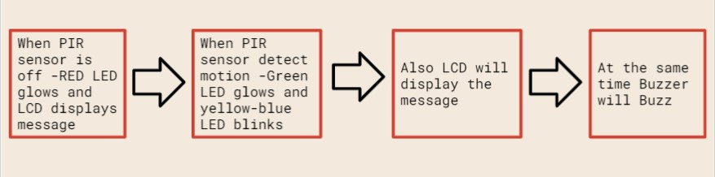

**Fig 4.1 Block diagram**

The fig1.1 shows a block diagram of the Security alarm system. It consists of Raspberry pi, PIR sensor, LCD, LEDs, resistors and buzzer.

1. **CIRCUIT DIAGRAM**

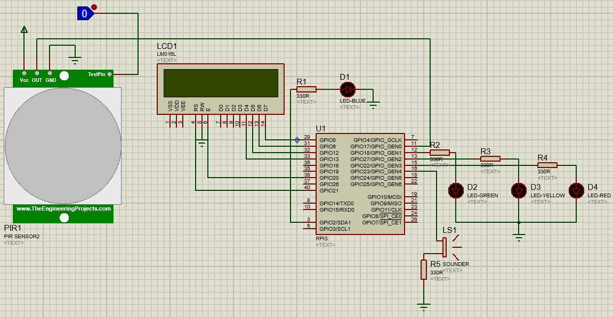

**Fig 4.2 Circuit diagram**

In this project, we implement a PIR Motion Sensor using Raspberry Pi by learning how to interface a PIR Sensor with Raspberry Pi. In this project, when the PIR Sensor detects any human motion, a buzzer is activated. The PIR motion sensor will sense motion when something that emits infrared rays (e.g., a human, animal, or anything that emits heat) moves in the range of the sensor's field or reach. PIR motion sensors are low power and inexpensive, so they're used in many products that detect motion. They can't say how many people are in the area and how close they are to the sensor; they just detect motion.Also LCD displays the message when motion is detected and at the same time buzzer will buzz.

**CHAPTER 5.**

The circuit diagram for this project can be referred from Fig. 4.1 and 4.2 which gives an overview of how the connections of the necessary components are made so as to achieve a security alarm system to better protect our possessions.This chapter gives information about the components and software used in our project.

**COMPONENT DESCRIPTION**

**Table 5.1 Components**

| **Sr No.** | **Name of the component** | **Value** |
| --- | --- | --- |
| 1. | Raspberry Pi | Raspberry Pi 3 |
| 2. | PIR Sensor | 5V |
| 3. | LCD | 16 X 2 |
| 4. | LED | Blue, Green,Yellow,Red |
| 5. | Resistor | Five 330Ω |
| 6. | Buzzer | Piezo |

Table 5.1 shows the components used in our project. Below are some of the major components used:

**RASPBERRY PI 3 :**

Raspberry Pi is a series of small single-board computers developed in the United Kingdom by the Raspberry Pi Foundation in association with Broadcom. Raspberry pi 3 is a development board in the Pi series. It can be considered as a single board computer that works on the LINUX operating system. The board not only has tons of features it also has terrific processing speed making it suitable for advanced applications. PI board is specifically designed for hobbyists and engineers who are interested in LINUX systems and IOT (Internet of Things). A powerful feature of the Raspberry Pi is the row of GPIO (general-purpose input/output) pins along the extreme right edge of the board. Like every Raspberry Pi chipset, it consists of a 40-pin GPIO. A standard interface for connecting a single-board computer or microprocessor to other devices is through General-Purpose Input/Output (GPIO) pins. GPIO pins do not have a specific function and can be customized using the software.

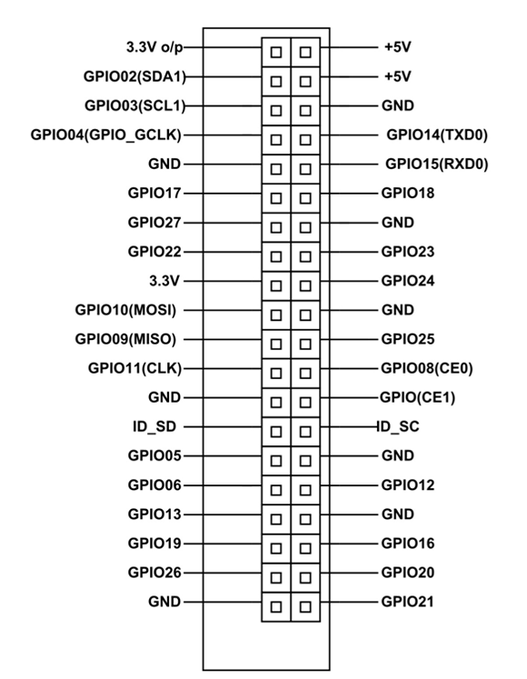

**Fig 5.1 Pin diagram of Raspberry Pi 3**

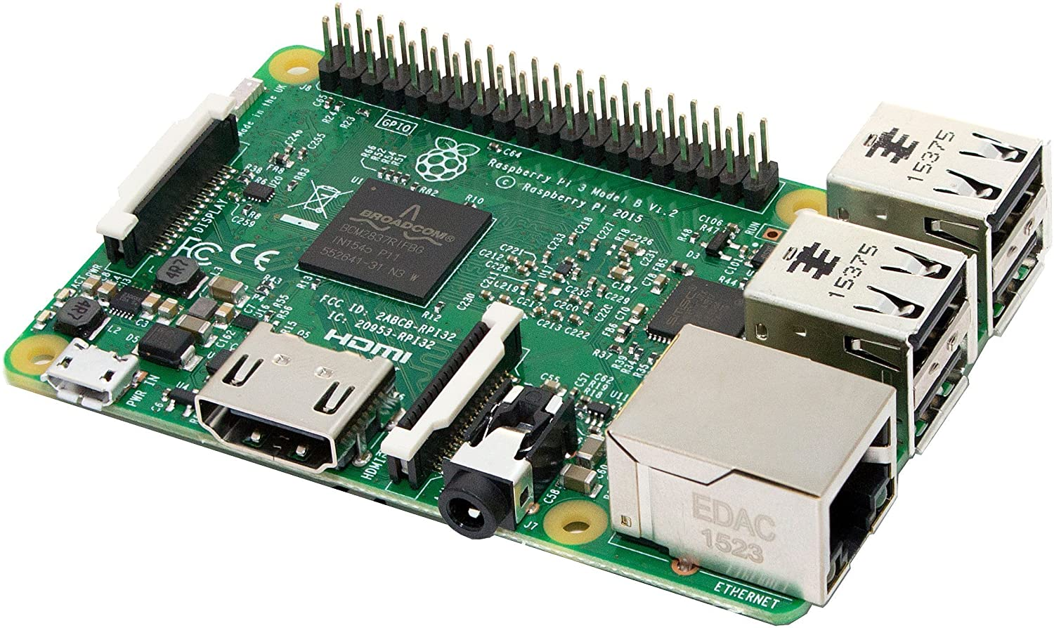

**Fig 5.2 Raspberry Pi 3**

**PIR SENSOR:**

PIR sensors allow you to sense motion, almost always used to detect whether a human has moved in or out of the sensor's range. They are small, inexpensive, low-power, easy to use and don't wear out. For that reason they are commonly found in appliances and gadgets used in homes or businesses. They are often referred to as PIR, "Passive Infrared", "Pyroelectric", or "IR motion" sensors. PIRs are basically made of a pyroelectric sensor (which you can see below as the round metal can with a rectangular crystal in the center), which can detect levels of infrared radiation. Everything emits some low level radiation, and the hotter something is, the more radiation is emitted. The sensor in a motion detector is actually split in two halves. The reason for that is that we are looking to detect motion (change) not average IR levels. The two halves are wired up so that they cancel each other out. If one half sees more or less IR radiation than the other, the output will swing high or low.

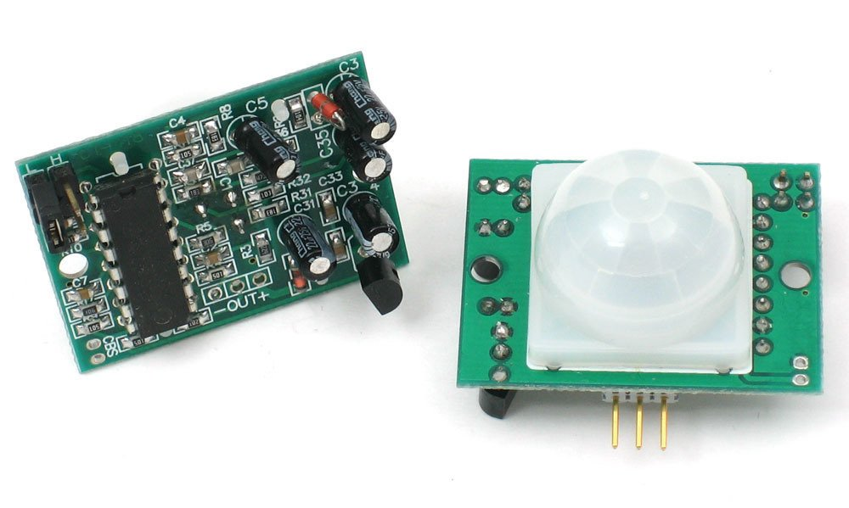

**Fig 5.3 PIR Sensor**

**LCD:**

The 16×2 LCD is named so because; it has 16 Columns and 2 Rows. There are a lot of combinations available like, 8×1, 8×2, 10×2, 16×1, etc. but the most used one is the 16×2 LCD. So, it will have (16×2=32) 32 characters in total and each character will be made of 5×8 Pixel Dots. The 16×2 LCD pinout is shown below.

* Pin1 (Ground/Source Pin): This is a GND pin of display, used to connect the GND terminal of the microcontroller unit or power source.
* Pin2 (VCC/Source Pin): This is the voltage supply pin of the display, used to connect the supply pin of the power source.
* Pin3 (V0/VEE/Control Pin): This pin regulates the difference of the display, used to connect a changeable POT that can supply 0 to 5V.
* Pin4 (Register Select/Control Pin): This pin toggles among command or data register, used to connect a microcontroller unit pin and obtains either 0 or 1(0 = data mode, and 1 = command mode).
* Pin5 (Read/Write/Control Pin): This pin toggles the display among the read or writes operation, and it is connected to a microcontroller unit pin to get either 0 or 1 (0 = Write Operation, and 1 = Read Operation).
* Pin 6 (Enable/Control Pin): This pin should be held high to execute Read/Write process, and it is connected to the microcontroller unit & constantly held high.
* Pins 7-14 (Data Pins): These pins are used to send data to the display. These pins are connected in two-wire modes like 4-wire mode and 8-wire mode. In 4-wire mode, only four pins are connected to the microcontroller unit like 0 to 3, whereas in 8-wire mode, 8-pins are connected to microcontroller unit like 0 to 7.
* Pin15 (+ve pin of the LED): This pin is connected to +5V
* Pin 16 (-ve pin of the LED): This pin is connected to GND.

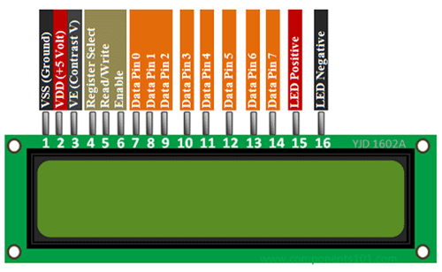

**Fig 5.4 LCD**

**5.1 HARDWARE**

NO Hardware

**5.2 SOFTWARE**

For our project, we have used Proteus for simulation. The Proteus Design Suite is a proprietary software tool suite used primarily for electronic design automation. It is developed in Yorkshire, England by Labcenter Electronics Ltd with offices in North America and several overseas sales channels. The software runs on the Windows operating system and is available in English, French, Spanish and Chinese languages.

The first version of what is now the Proteus Design Suite was called PC-B and was written by the company chairman, John Jameson, for DOS in 1988. Schematic Capture support followed in 1990, with a port to the Windows environment shortly thereafter. Mixed mode SPICE Simulation was first integrated into Proteus in 1996 and microcontroller simulation then arrived in Proteus in 1998. Shape based auto routing was added in 2002 and 2006 saw another major product update with 3D Board Visualization. More recently, a dedicated IDE for simulation was added in 2011 and MCAD import/export was included in 2015. Feature led product releases are typically biannual, while maintenance-based service packs are released as required.

The Proteus Design Suite is a Windows application for schematic capture, simulation, and PCB layout design. It can be purchased in many configurations, depending on the size of designs being produced and the requirements for microcontroller simulation. All PCB Design products include an auto router and basic mixed mode SPICE simulation capabilities. The software is used mainly by electronic design engineers and technicians to create schematics and electronic prints for manufacturing printed circuit boards. The Proteus Design Suite is a Windows application for schematic capture, simulation, and PCB (Printed Circuit Board) layout design.

Schematic capture in the Proteus Design Suite is used for both the simulation of designs and as the design phase of a PCB layout project. It is therefore a core component and is included with all product configurations. Proteus is a virtual system modelling and circuit simulation application. The suit combines mixed mode SPICE circuit simulation, animated components and microprocessor models to facilitate co-simulation of complete microcontroller-based designs.

The microcontroller simulation in Proteus works by applying either a hex file or a debug file to the microcontroller part on the schematic. It is then co-simulated along with any analog and digital electronics connected to it. This enables it's used in a broad spectrum of project prototyping in areas such as motor control, temperature control and user interface design. It also finds use in the general hobbyist community and, since no hardware is required, is convenient to use as a training or teaching tool.

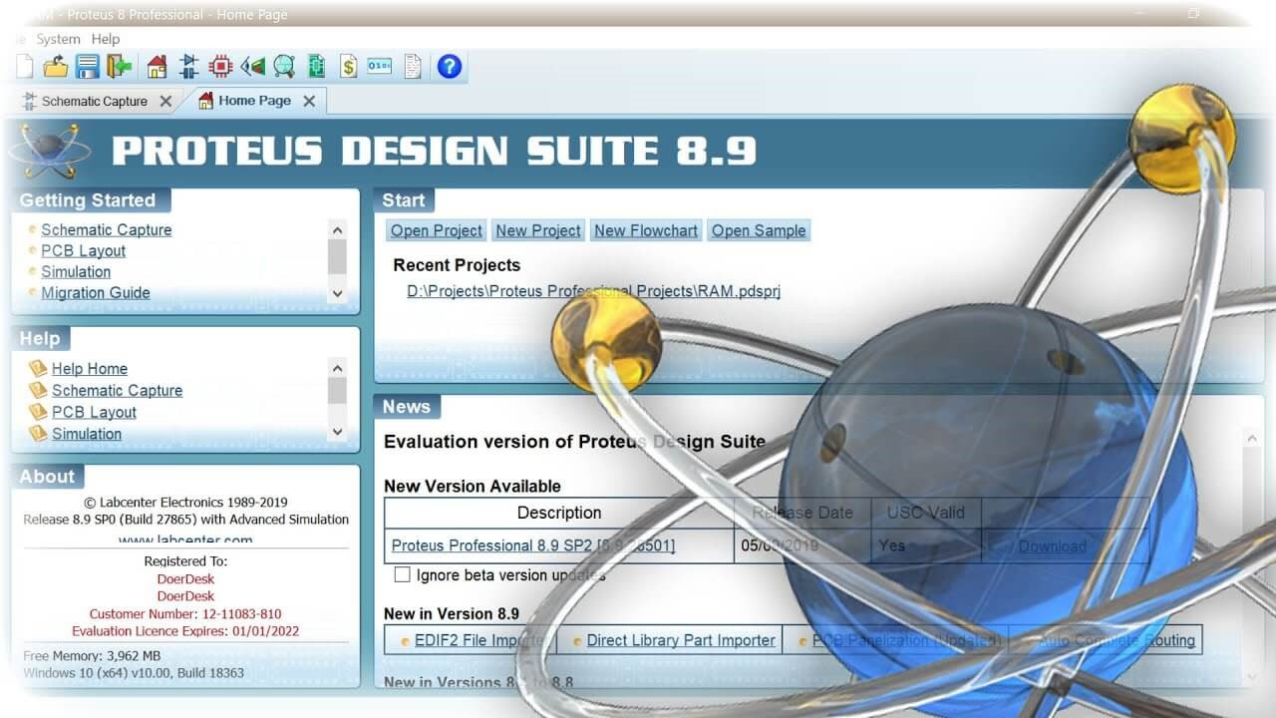

**Fig 5.5 Proteus Software**

**CHAPTER 6.**

**SOFTWARE IMPLEMENTATION**

This chapter gives information about software implementation of our project.

Conventionally, the designing process requires only the estimation based on theoretical understanding. With the help of assisted software, simulation can be done. From this simulation result, it gives the guideline flexibility to refine the circuit for example the outcome or the result does not satisfy the requirement. For this project, Proteus software is used. This software not only helps to speed up the process of designing, but also avoid unnecessary mistakes before the actual thing is built.

Proteus simulation is a software tool that can design a schematic diagram and make a simulation of the circuit. It is easy to use this program because we can design our own circuit and simulate it. We can check if the simulations work properly or not and make changes accordingly. We made a circuit using raspberry pi 3 and LCD. We added the code for the microcontroller using the feature firmware in which we can write our source code. We have used Python programming language in our project.We assembled the components according to the circuit diagram shown in fig 4.2. After assembling the components and completing the circuit, we simulated the circuits to observe the results.



**Fig 6.1 Schematic diagram of the circuit**

**CHAPTER 7.**

**SIMULATION RESULTS**

This chapter shows the simulation results of our project.

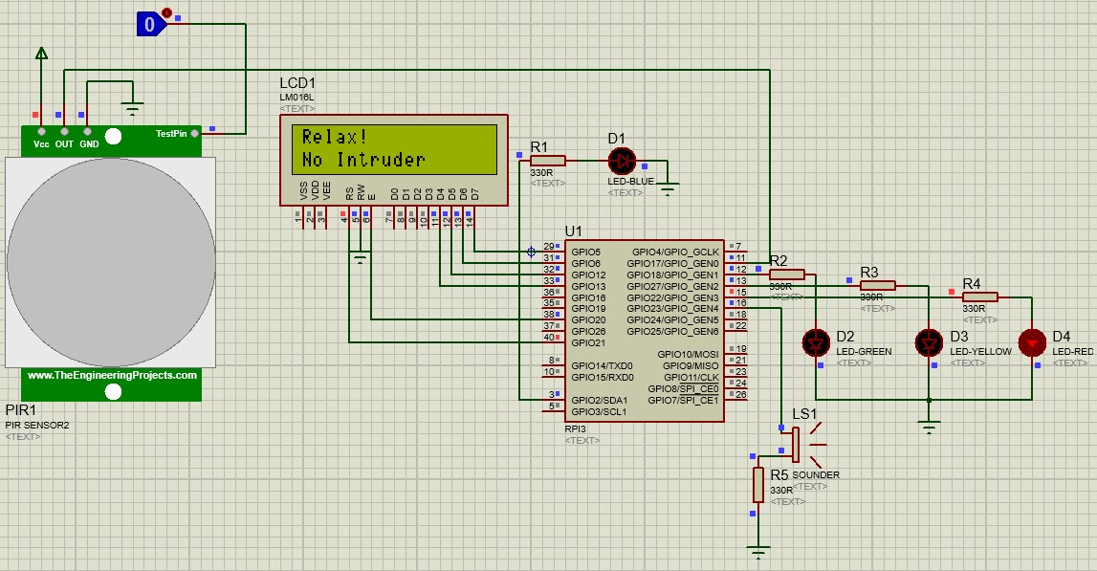

**Fig 7.1 Simulation result when motion is not detected**

* Fig 7.1 shows the result when motion is not detected by the PIR sensor .When the logic toggle is ‘0’ that means the motion is not detected by the PIR sensor.
* In this case, the red LED will glow and the LCD will display the message “Relax! No Intruder!”

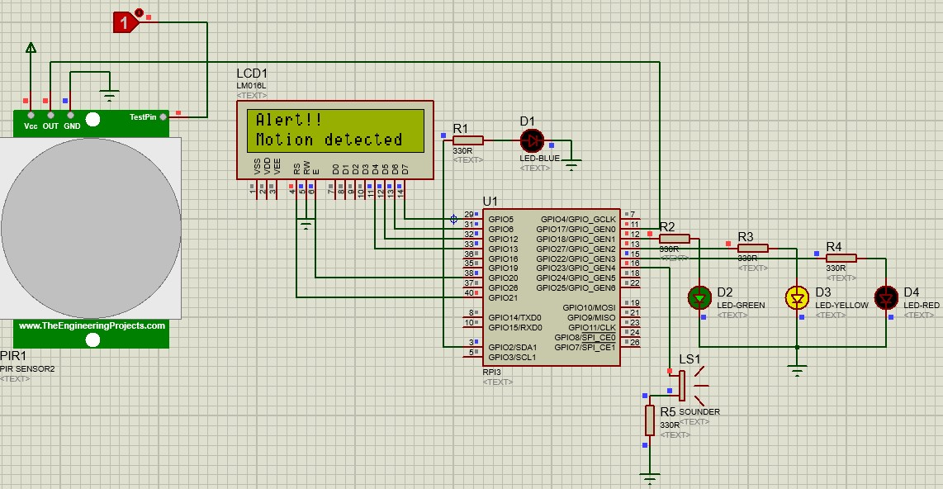

**Fig 7.2 Simulation result when motion is detected**

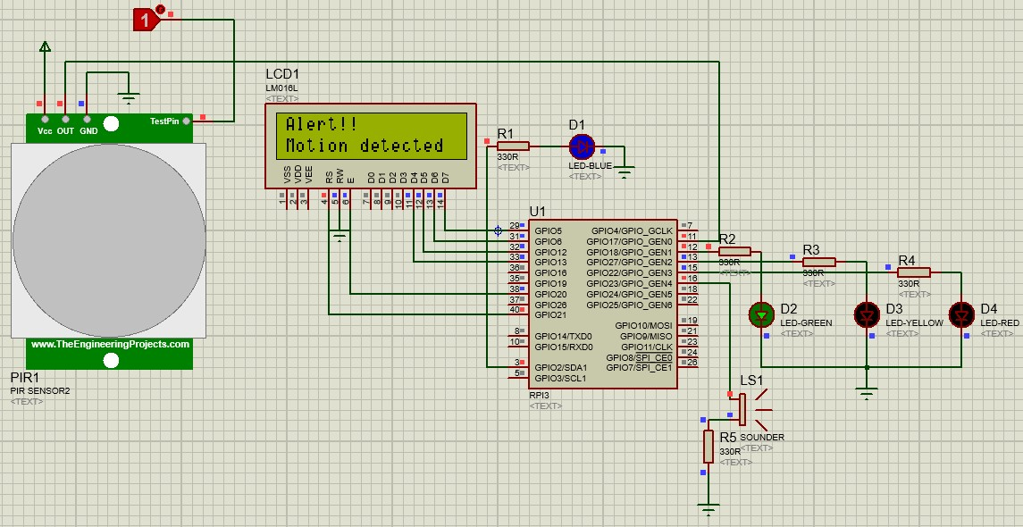

**Fig 7.3 Simulation result when motion is detected and the LED blinks**

* Fig 7.2 and 7.3 shows results when motion is not detected by the PIR sensor. When the logic toggle is ‘1’ that means the motion is detected.
* In this case, the PIR output goes high which will be read by Raspberry pi, which in turn will activate the lighting and alarm system, which can be seen in fig 7.2.
* It can be seen in fig 7.3 that the green LED will glow and the yellow and blue LEDs will blink and at the same time the buzzer will buzz and the LCD will display the message “Alert! Motion Detected!”.

**CHAPTER 8.**

**CONCLUSIONS**

The security system has been aimed to design such a way that it could fulfill the needs of the user for a particular surveillance area. It has countless applications and can be used in different environments and scenarios. For instance, it can be used by any person working in industry to be aware of the activity happening at their own working places, in their absence. While it can be used for spy purposes at bank lockers, storage houses.

Burglary is the most common cause of property losses. Different types of detectors are used, which are far more effective than human senses, to detect the unwanted changes in the property areas. Too many types of systems are in use for unwanted change detection.ation to users about what is happening in a surveillance area by the sound of buzzer.

The objective of this project is to give awareness of the advancement in technology using internet of things (IOT) of the security alarm system and to create awareness regarding the security measures one has to take regularly due to increasing in break-in and abduction in the world nowadays and the challenges faced when the security system is linked to an internet and how to protect the whole system against cyber criminals attacks[1].

This project helps to meet the need to automate life to give advantage of technological advancements. This project can be implemented both in apartments and general stores as well. So, in this way there is much use of this system to be applied for our safety purpose.

**CHAPTER 9.**

**FUTURE SCOPE**

The developed system can also be used in industrial and commercial applications such as offices, warehouses and other areas where some areas are reserved for authorized personnel only or other places where safety and precautions are of primary concerns such as the internet server room of a big MNC from where corporate data can be stolen[2]. The system can also be easily upgraded to add extra safety features such as cameras, motion detection sensors, etc. for increased safety. The system can also further be developed by adding an RFID scanner so that the authorized users need only carry a RFID or NFC tag with them on their person. The RFID scanner will work by scanning the tag wirelessly and if the user is authorized to enter, the alarm system will be disabled for some time so that the user can enter.

We can add a keypad to arm or disarm the alarm. We can determine the position of the intruder and then send a SMS to the concerned authorities[3].There are several recommendations that can make the motion detector system more reliable and efficient for the future[4].

1. **Use of GSM Modem:** This will increase the ability of remotely receiving a notification and controlling a set of actions. For example, if used in a home, the user can make the system switch on a CD player that will create an impression that someone is inside the house.
2. **Making GUI (Graphical User Interface):** To make this motion sensor more friendly
3. **Using a more powerful sensor:** It will enhance the system by giving it the counting ability.
4. **Using spy cameras:** For taking pictures that will be sent to the user in order to know the kind of object that has been detected within the detection range.
5. **Using an ultrasonic sensor:** For distance measuring capability.

**REFERENCES**

1. Mehmet Çavaş and Muhammad Baballe Ahmad,”A Review advancement of security alarm system using internet of things (IoT)”,International Journal of New Computer Architectures and their Applications (IJNCAA).
2. A Anitha,”Home security system using internet of things”,IOP Conference Series: Materials Science and Engineering, Volume 263, Issue 4.
3. Suman Pandit ,Shakyanand Kamble, Vinit Vasudevan,”Home Security Alarm System Using Arduino”,Vidyalankar institute of technology.
4. Ochieng, Francis Omondi ,”Development of simple motion sensing component”, School of information sciences, Moi University.
5. A.N. Ansari, M. Sedky, N. Sharma, A. Tyagi,’An Internet of Things Approach for Motion Detection using Raspberry Pi’, International Conference on Intelligent Computing and Internet of Things(ICIT), pp.131-134.
6. opensource.com/article/20/11/motion-detection-raspberry-pi
7. www.researchgate.net/publication/342120813_Smart_Motion_Detection_System_using_Raspberry_Pi
8. www.safewise.com/home-security-faq/how-motion-detectors-work/
9. www.electronicshub.org/pir-motion-sensor-using-raspberry-pi/
10. V. Brahmeswara Rao K Durga Harish Kumar, N V Upendra Kumar and K Deepak, “Arduino based two axis solar tracking by using servo mechanism”, International Journal of Modern Trends in Science and Technology, vol. 03, Special Issue 02, 2017 pp 41-44.
11. Venkat Margapuri Department of Computer Science Kansas State University Manhattan, USA.

**APPENDIX**

**SOURCE CODE:**

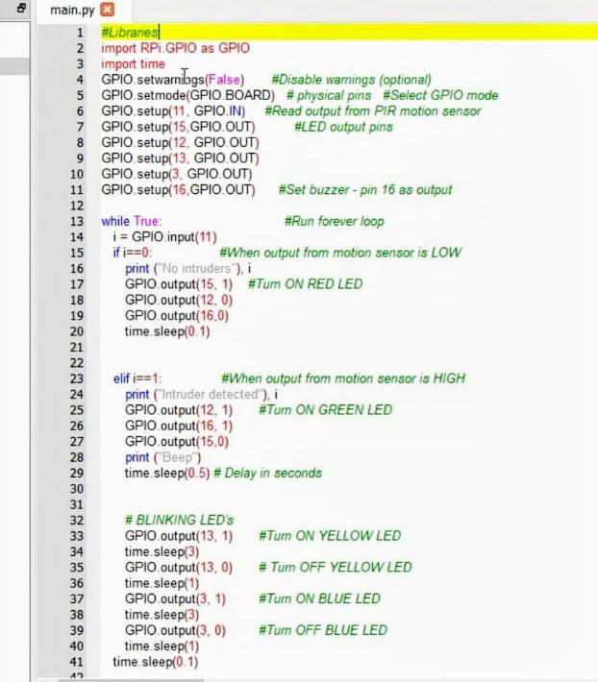

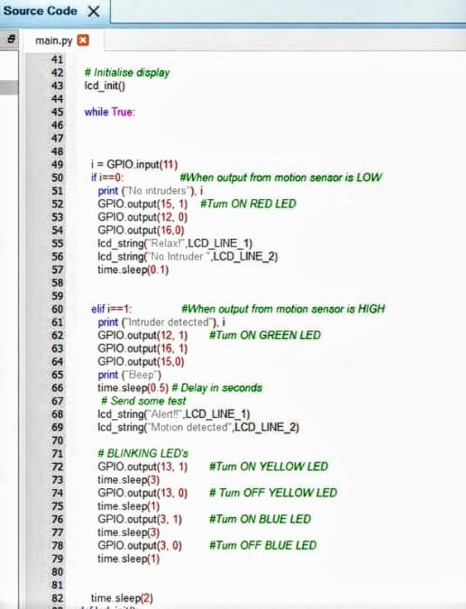

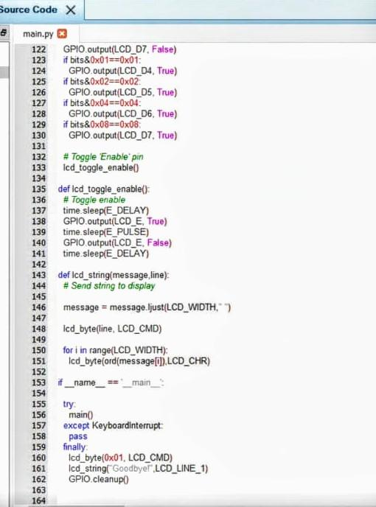

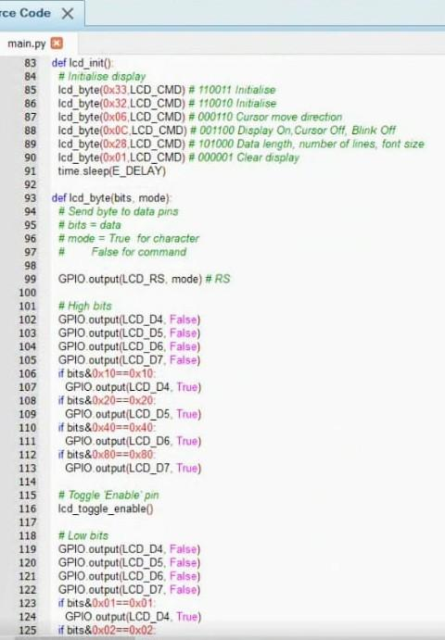**General Instructions**

1. Text should be printed on front and correct side of the watermark on quality bond paper

**Paper size**- A4, 70 to 85 gsm paper

**Margins**: Top-1”, Bottom-1”, Left -1.5”, Right- 1”

1. **Font:** Times New Roman
   * + Font Size For Chapter heading -14(Bold upper case)
     + Font Size For main titles -12(Bold upper case)
     + Font Size For Subtitles -12(Bold Title case)
     + Font Size For Text Matter -12
     + Line Spacing -1.5 Lines
     + **Figure/Photo/Graph Caption:** Figure/Photo/Graph should be Central align to page. Figure/Photo/Graph caption should be below the Figure/Photo/Graph, left align to Figure/Photo/Graph in Title case, 10 TNR, Bold.
     + **Table Caption:** Table should be Central align to page. Table caption should be above the Table, center align to Table in Title case, 10 TNR, Bold.

* Figure/Table/Photo/Graph Should Be Numbered Chapter Wise As Fig 1.1, 1.2, 2.1
* **Text:** Main Title No’s should be 1.1, 1.2 etc for chapter no 1, 2.1 2.2 for chapter 2 etc. Subtitle 1.1.1, 1.1.2 etc.
* Reference of Figure Should Be Given In Text Matter
* Total Number of Typed Pages Shall be minimum 40

1. **Students are supposed to encouraged for participation in inter and intra college level, University level and National level project competitions and demonstration.**
2. **References**

**For Books:-**

Name of Author, "Title of Book", Name of Publisher, Vol. No., Year of Publication,

Page no.

**Example:**

Singiresu Rao, "The FEM in Engineering", BH Publication, 3rd Edition,1998, PP-  
 22-30